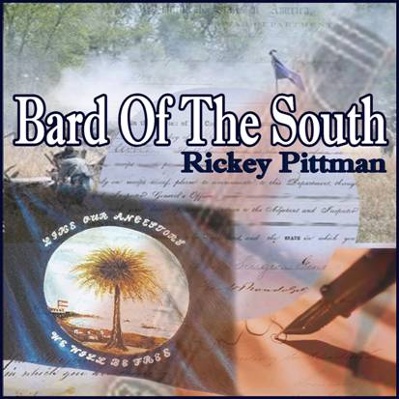 

Rickey Pittman

**Storyteller/Author/Folksinger**

**School & Library Programs**

**Scots-Irish, Civil War, Louisiana History**

**Award winning author of *The Scottish Alphabet* (and other books by Pelican Publishing. *Each presentation is in costume, with a visual show and tell table, and with guitar/vocal music. A culturally enriching experience!**

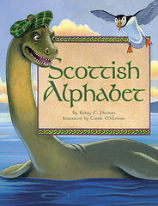

All Day Program for $400.00

(Special rate for anywhere in Louisiana, Arkansas or Missouri. Lodging and travel expenses are paid by author.)

**Contact Information**

#### Phone: 318-547-2906

#### Email: rickeyp@bayou.com http://www.bardofthesouth.com/

**Author of *The Scottish Alphabet* (and other books by Pelican Publishing.**

**\*Each presentation is in costume, with a visual show and tell table, and with guitar/vocal music. A culturally enriching experience!**