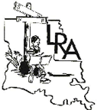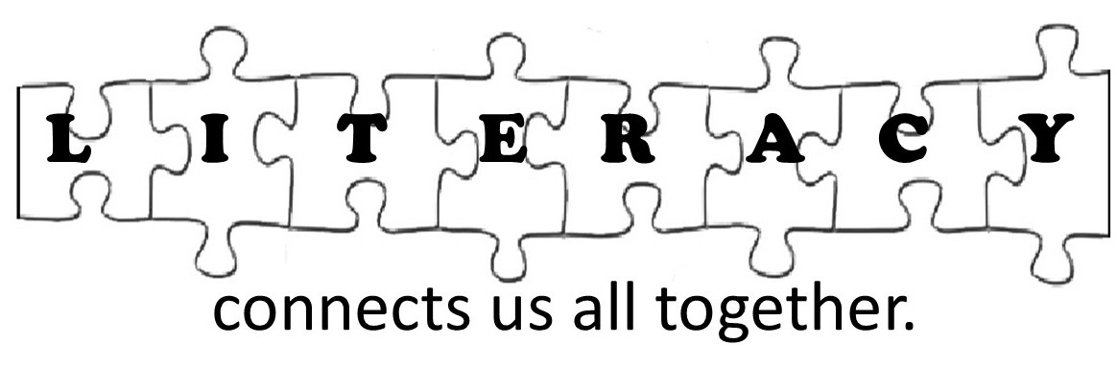
Important LRA Dates for 2020-2021
Compiled by Gerri Settoon, LRA Member At Large

*ILA 2020 Conference cancelled!*

2020
September 8 | International Literacy Day. Go to ILA’s website for Literacy Day kits: https://www.literacyworldwide.org/meetings-events/international-literacy-day
October 1 | Janet Langlois Travel Grant application due; www.lareading.org
October 17 | LRA Meeting via ZOOM
October 29 | Jumpstart’s Read for the Record; https://www.jstart.org/read-for-the-record/  Book: Evelyn Del Rey Is Moving Away by Meg Medina
November 15 | Final date for Tax filing Form 990N with IRS for LRA and any councils with a separate EIN number other than LRA’s
November 15 | Exemplary Schools Award Packet postmarked
November 28 | Exemplary Reading Program Award packet due from schools to ILA at http://literacyworldwide.org
December 15 | Award of Excellence application due to ILA from LRA President
December 15 | ILA Advocacy Award application due by Chairperson
December 15 | Local Community Service Award Application due to ILA;  http://literacyworldwide.org
December 15 | Honor Council Award application due online to ILA by local reading council Presidents, https://www.literacyworldwide.org/about-us/awards-grants
2021
January 9 | LRA Meeting via ZOOM
February 1-15 | Exemplary Reading Program Award site visits
February 1 | Young Authors entries due to LRA Chairperson www.lareading.org
February | African-American Read-in Chain on any day of the month www.ncte.org/action/aari ; http://www.readwritethink.org/classroom-resources/calendar-activities/take-part-african-american-20419.html
February 7-13 | Literacy Week www.lareading.org
February 28 | Educators as Authors entries due to LRA Chairperson
February 28 | Exemplary Reading School winner’s packet reported to ILA
March 2 | Read Across America/Dr. Seuss’s birthday; http://www.nea.org/grants/886.htm
March 15 | Children’s and Young Adults’ Book Award for new author application due
April 1 | LRA Scholarship application and Awards and Citations nominations due to LRA Chairpersons www.lareading.org
April 10 | LRA Meeting via ZOOM
May 1 | LRA Literacy Award due to LRA Literacy Committee Chair, www.lareading.org
May 4 | National Teachers Day
May 3-7 | National Teachers Appreciation Week
May 15 | Local Reading Council Officers Report due to State Coordinator, LRA President, and V.P.
May 20 | LRA Honor Council Award application due to LRA Membership Director www.lareading.org
June 1 | Constance McCullough International Research Grant application due
June 1 | Elva Knight Research Grant application due
June 1 | Erwin Zolt Digital Literacy Game Changer Award application due
June 1 | Helen M. Robinson Grant for Doctoral student application due
June 1 | Jeannie S. Chall Research Grant
June 1 | Jerry Johns Outstanding Teacher Educator in Reading Award application due
June 1 | Leaders Inspiring Readers Award application due
June 1 | Maryann Manning Special Service Award application due
June 1 | Nila Banton Smith Teacher as Researcher Grant application due
June 1 | Regie Routman Teacher Recognition Grant application due to ILA (Grades K-8; $2500)
June 1 | Steven A. Stahl Research Grant application due
June 1 | Timothy & Cynthia Shanahan Outstanding Dissertation Award
June 1 | William S. Gray Citation of Merit
June 30 | LRA State Officers Report due to ILA
July 1 | R.E.A.D.Literacy Program starts in local reading councils
July TBA | LRA Leadership Training & LRA Meeting
On-going throughout the year | Celebrate Literacy Award
October 14-17, 2021 | ILA 2021 Conference, Indianapolis, IN

