CommitteesLouisiana House of Representatives
2020 - 2024
https://house.louisiana.gov/H_Reps/H_Reps_FullInfo

By Full Info
Click on Image/Name for Full Member Information
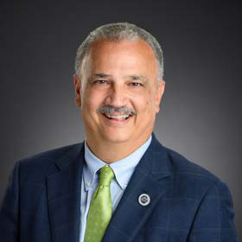

Adams, Roy Daryl
Dist 62
Independent
P. O. Box 217 Jackson, LA 70748
(225) 634-7470
hse062@legis.la.gov
Senate Dist. 15, 17, and 32
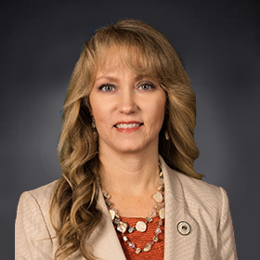

Amedée, Beryl
Dist 51
Republican
302 School Street Houma, LA 70360
(985) 858-2967
amedeeb@legis.la.gov
Senate Dist. 2, 17, 20, and 21
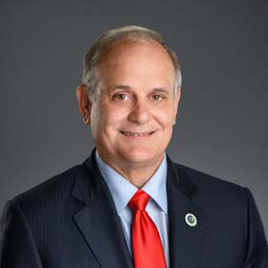

Bacala, Tony
Dist 59
Republican
15482 Airline Hwy. Suite A Prairieville, LA 70769
(225) 677-8020
bacalat@legis.la.gov
Senate Dist. 18
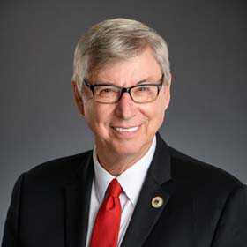

Bagley, Larry
Dist 7
Republican
671 Hwy. 171 Suite E Stonewall, LA 71078
(318) 925-9588
bagleyl@legis.la.gov
Senate Dist. 31 and 38

Beaullieu IV, Gerald "Beau"
Dist 48
Republican
800 S. Lewis Street Suite 206 New Iberia, LA 70560
(337) 373-4051
hse048@legis.la.gov
Senate Dist. 22 and 23

Bishop, Stuart J.
Dist 43
Republican
P. O. Box 80993 Lafayette, LA 70508
(337) 981-7409
bishops@legis.la.gov
Senate Dist. 23
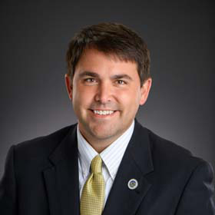

Bourriaque, Ryan
Dist 47
Republican
122 North State Street Suite 100 Abbeville, LA 70510
(337) 893-5035
hse047@legis.la.gov
Senate Dist. 25, 26, and 30
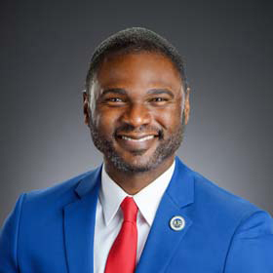

Brass, Ken
Dist 58
Democrat
22140 Highway 20 Suite C Vacherie, LA 70090
(225) 265-9005
brassk@legis.la.gov
Senate Dist. 2, 17, and 18
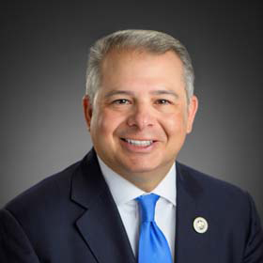

Brown, Chad
Dist 60
Democrat
57835 Plaquemine Street Plaquemine, LA 70764
(225) 687-2410
brownc@legis.la.gov
Senate Dist. 2 and 17
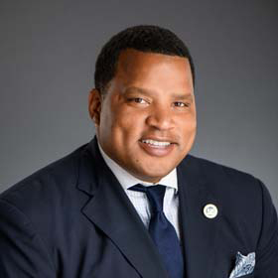

Bryant, Marcus Anthony
Dist 96
Democrat
800 South Lewis Street Suite 201-B New Iberia, LA 70560
(337) 373-9380
hse096@legis.la.gov
Senate Dist. 22 and 24

Butler, Rhonda Gaye
Dist 38
Republican
5592 Vidrine Road Ville Platte, LA 70586
(337) 363-3900
hse038@legis.la.gov
Senate Dist. 22, 24, and 28
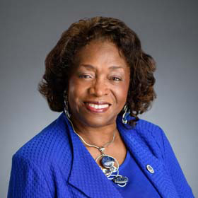

Carpenter, Barbara
Dist 63
Democrat
1975 Harding Blvd. Baton Rouge, LA 70807
(225) 771-5674
carpenterb@legis.la.gov
Senate Dist. 14 and 15
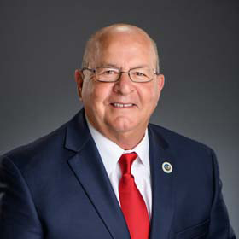

Carrier, R. Dewith
Dist 32
Republican
P. O. Box 593 Oakdale, LA 71463
(318) 335-0206
hse032@legis.la.gov
Senate Dist. 28 and 30
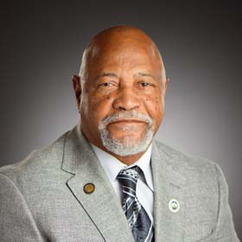

Carter, Sr., Wilford
Dist 34
Democrat
1025 Mill Street Lake Charles, LA 70601
(337) 491-2320
hse034@legis.la.gov
Senate Dist. 25 and 27
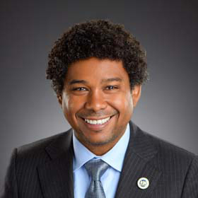

Carter, Gary
Dist 102
Democrat
2401 Westbend Parkway Suite 3071 New Orleans, LA 70114
(504) 361-6600
carterg@legis.la.gov
Senate Dist. 3 and 7

Carter, Robby
Dist 72
Democrat
225 NW Central Avenue Amite, LA 70422
(985) 748-2245
carterr@legis.la.gov
Senate Dist. 6, 12, and 17
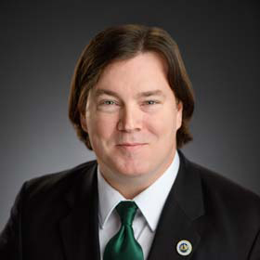

Cormier, Mack
Dist 105
Democrat
hse105@legis.la.gov
Senate Dist. 7 and 8
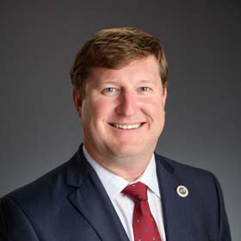

Coussan, Jean-Paul
Dist 45
Republican
2508-A Johnston Street Lafayette, LA 70503
(337) 262-2400
coussanjp@legis.la.gov
Senate Dist. 23 and 26
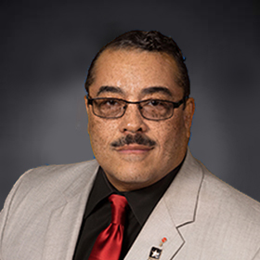

Cox, Kenny R.
Dist 23
Democrat
781 Hwy. 494 Natchitoches, LA 71457
(855) 844-8583
coxk@legis.la.gov
Senate Dist. 29, 31, and 38
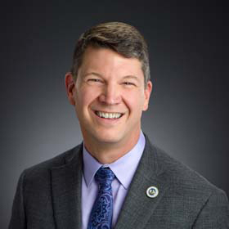

Crews, Raymond J.
Dist 8
Republican
4921 Shed Road Suite 200 Bossier City, LA 71111-5477
(318) 716-7532
crewsr@legis.la.gov
Senate Dist. 36 and 37
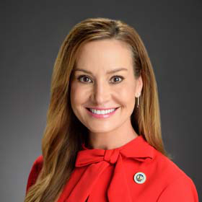

Davis, Paula
Dist 69
Republican
7902 Wrenwood Blvd. Suite D Baton Rouge, LA 70809
(225) 362-5301
davisp@legis.la.gov
Senate Dist. 6, 15, and 16
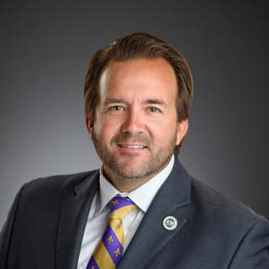

DeVillier, Phillip
Dist 41
Republican
P. O. Box 986 Eunice, LA 70535
(337) 457-0194
devillierp@legis.la.gov
Senate Dist. 24, 25, 26, and 28

Deshotel, Daryl Andrew
Dist 28
Republican
312 North Main Street Marksville, LA 71351
(318) 253-8891
hse028@legis.la.gov
Senate Dist. 28 and 32

Vacant - District 54
Dist 54
Republican
P. O. Box 780 Cut Off, LA 70345
(985) 258-1270
Senate Dist. 8, 19, and 20
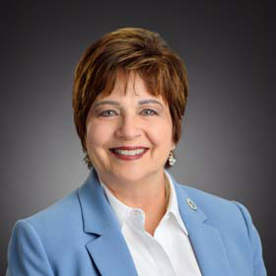

DuBuisson, Mary
Dist 90
Republican
P. O. Box 44 Slidell, LA 70459
(985) 645-3592
hse090@legis.la.gov
Senate Dist. 1
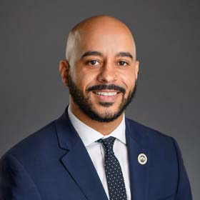

Duplessis, Royce
Dist 93
Democrat
643 Magazine Street Suite 302 New Orleans, LA 70130
(504) 568-2740
duplessisr@legis.la.gov
Senate Dist. 3, 4, and 5
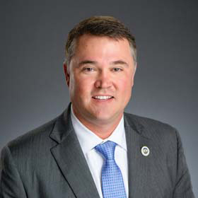

Dwight, Stephen
Dist 35
Republican
P. O. Box 12703 Lake Charles, LA 70612-2703
(337) 491-2315
dwights@legis.la.gov
Senate Dist. 27 and 30
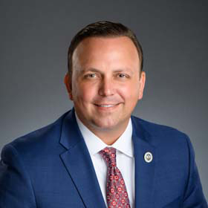

Echols, Michael Charles
Dist 14
Republican
8823 Highway 165 N. Suite 1 Monroe, LA 71203
(318) 598-4010
hse014@legis.la.gov
Senate Dist. 33, 34, and 35
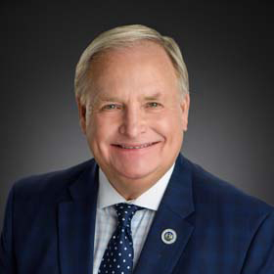

Edmonds, Rick
Dist 66
Republican
3931 S. Sherwood Forest Blvd. Suite 200 Baton Rouge, LA 70816
(225) 295-9240
edmondsr@legis.la.gov
Senate Dist. 6, 14, and 16

Edmonston, Kathy
Dist 88
Republican
2115 S. Burnside Suite C Gonzales, LA 70737
(225) 647-5646
hse088@legis.la.gov
Senate Dist. 2 and 18
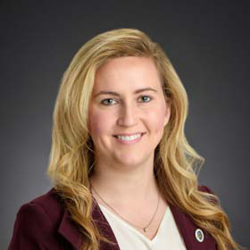

Emerson, Julie
Dist 39
Republican
306 North Church Street Carencro, LA 70520
(337) 886-4687
emersonj@legis.la.gov
Senate Dist. 24 and 26
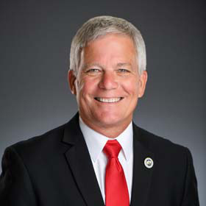

Farnum, Les
Dist 33
Republican
P. O. Box 558 Sulphur, LA 70664
(337) 625-8569
hse033@legis.la.gov
Senate Dist. 27 and 30

Firment, Michael "Gabe"
Dist 22
Republican
Physical Address: 181 Barron Road Pollock, LA 71467-3643 Mailing: P. O. Box 640 Pollock, LA 71467
(318) 765-9606
hse022@legis.la.gov
Senate Dist. 29, 31, 32, and 35
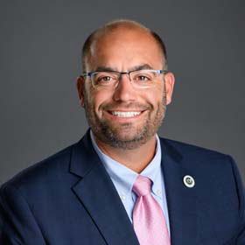

Fontenot, Bryan
Dist 55
Republican
406 W 3rd Street Suite 107 Thibodaux, LA 70301-3014
(985) 447-0999
hse055@legis.la.gov
Senate Dist. 2, 19, 20, and 21

Freeman, Aimee Adatto
Dist 98
Democrat
8600 Oak Street New Orleans, LA 70118-1222
(504) 861-1614
hse098@legis.la.gov
Senate Dist. 5 and 9
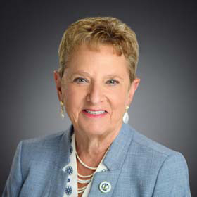

Freiberg, Barbara Reich
Dist 70
Republican
5800 One Perkins Place Suite 7A Baton Rouge, LA 70808
(225) 763-3500
hse070@legis.la.gov
Senate Dist. 14 and 16
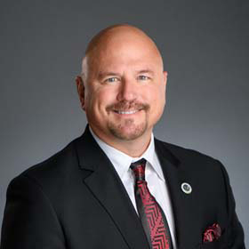

Frieman, Lawrence "Larry"
Dist 74
Republican
P. O. Box 1893 Abita Springs, LA 70420
(985) 400-4670
hse074@legis.la.gov
Senate Dist. 1, 11, and 12
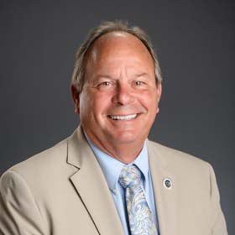

Gadberry, Foy Bryan
Dist 15
Republican
4920 Cypress Street Suite 3C West Monroe, LA 71291
(318) 396-8080
hse015@legis.la.gov
Senate Dist. 32, 33, and 35
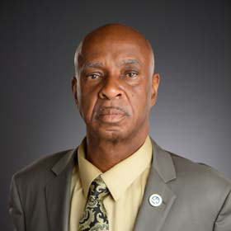

Gaines, Randal L.
Dist 57
Democrat
425 W. Airline Hwy. Suite K LaPlace, LA 70068-3818
(985) 652-1228
gainesr@legis.la.gov
Senate Dist. 2 and 19
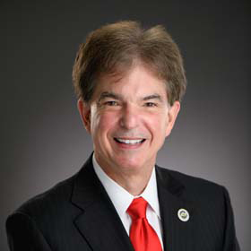

Garofalo, Raymond E.
Dist 103
Republican
100 Port Blvd. Chalmette, LA 70043
(504) 277-4729
garofalor@legis.la.gov
Senate Dist. 1 and 3
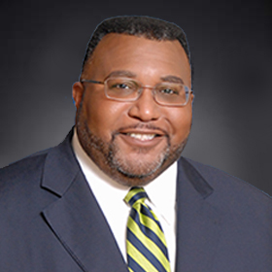

Glover, Cedric
Dist 4
Democrat
1341 Russell Road Shreveport, LA 71107
(318) 221-7775
gloverc@legis.la.gov
Senate Dist. 38 and 39
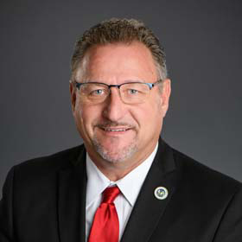

Goudeau I, Jonathan
Dist 31
Republican
3639 Ambassador Caffery Pkwy. Suite 214 Lafayette, LA 70503
(337) 347-7077
hse031@legis.la.gov
Senate Dist. 23 and 26
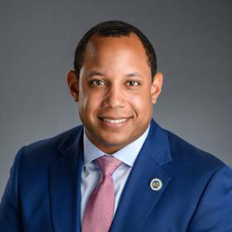

Green Jr., Kyle M.
Dist 83
Democrat
6641 Westbank Expwy. Suite D Marrero, LA 70072
(504) 349-8788
hse083@legis.la.gov
Senate Dist. 3 and 8
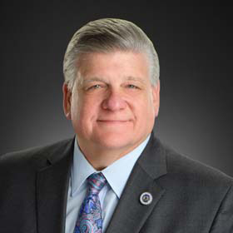

Harris, Lance
Dist 25
Republican
P. O. Box 13555 Alexandria, LA 71315-3555
(318) 767-6095
harrisl@legis.la.gov
Senate Dist. 29 and 31
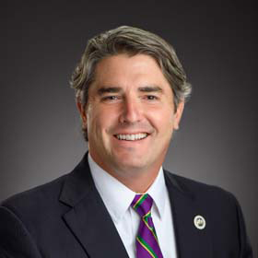

Henry, Charles Alexander
Dist 82
Republican
P. O. Box 231474 Jefferson, LA 70183
(504) 655-6887
hse082@legis.la.gov
Senate Dist. 5, 9, and 10
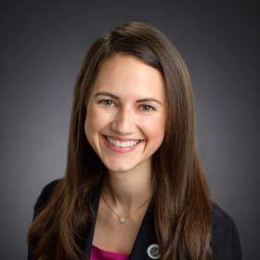

Hilferty, Stephanie
Dist 94
Republican
3331 Severn Ave. Suite 206 Metairie, LA 70002
(504) 885-4154
hilfertys@legis.la.gov
Senate Dist. 4 and 9
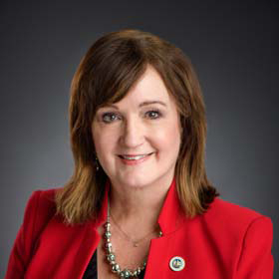

Hodges, Valarie
Dist 64
Republican
35055 La. Hwy. 16 Suite 2A Denham Springs, LA 70706
(225) 791-2199
hodgesv@legis.la.gov
Senate Dist. 6, 13, 15, and 17
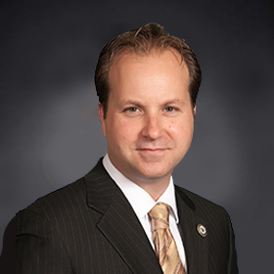

Hollis, Paul
Dist 104
Republican
600 N. Highway 190 Suite 202A Covington, LA 70433-5083
(985) 871-4680
hollisp@legis.la.gov
Senate Dist. 1 and 11
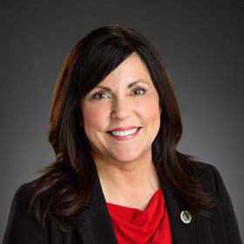

Horton, Dodie
Dist 9
Republican
954 Hwy. 80 Suite 400 Haughton, LA 71037
(318) 949-2463
hortond@legis.la.gov
Senate Dist. 36 and 37
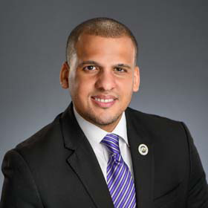

Hughes, Jason
Dist 100
Democrat
P. O. Box 872461 New Orleans, LA 70187
(504) 246-9707
hse100@legis.la.gov
Senate Dist. 3 and 4
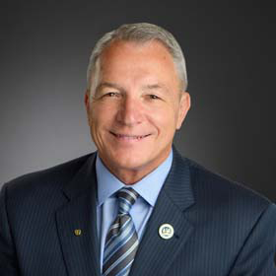

Huval, Mike
Dist 46
Republican
110 N. Main Street Breaux Bridge, LA 70517
(337) 332-3331
huvalm@legis.la.gov
Senate Dist. 21, 22, and 24

Illg Jr., John R.
Dist 78
Republican
9523 Jefferson Hwy. Suite A River Ridge, LA 70123 *Not ADA accessible. Please call to make accommodations.
(504) 736-7030
hse078@legis.la.gov
Senate Dist. 10
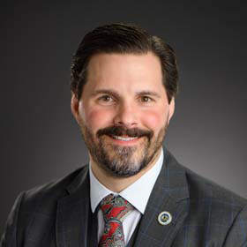

Ivey, Barry
Dist 65
Republican
P. O. Box 78286 Baton Rouge, LA 70837
(225) 261-5739
iveyb@legis.la.gov
Senate Dist. 6, 13, 15, and 16
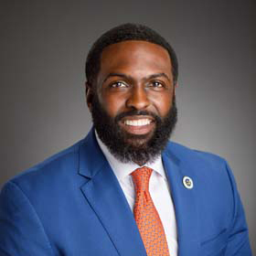

James, Edward C. "Ted"
Dist 101
Democrat
445 N. 12th Street Baton Rouge, LA 70802
(225) 343-3633
james.ted@legis.la.gov
Senate Dist. 14 and 15
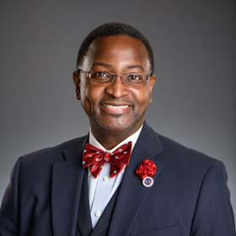

Jefferson, Patrick O.
Dist 11
Democrat
504 N. Main Street Homer, LA 71040
(318) 927-2519
jeffersonpo@legis.la.gov
Senate Dist. 29, 33, 35, and 36
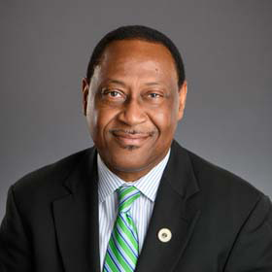

Jenkins, Sam
Dist 2
Democrat
2419 Kings Hwy. Shreveport, LA 71103
(318) 632-5970
jenkinss@legis.la.gov
Senate Dist. 37 and 39
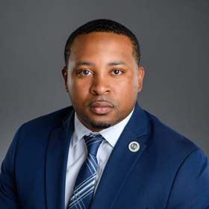

Johnson, C. Travis
Dist 21
Democrat
200 Advocate Row Suite D Vidalia, LA 71373
(225) 308-4269
hse021@legis.la.gov
Senate Dist. 32 and 34

Johnson, Mike
Dist 27
Republican
2757 Hwy. 28 East Pineville, LA 71360
(318) 487-5377
hse027@legis.la.gov
Senate Dist. 29, 31, 32, and 35
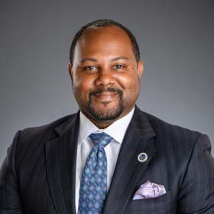

Jones, Frederick
Dist 16
Democrat
110 South Washington Street Bastrop, LA 71220 Mailing Address: 1605 Lamy Lane Suite D Monroe, LA 71201
(318) 556-7001
hse016@legis.la.gov
Senate Dist. 33 and 34
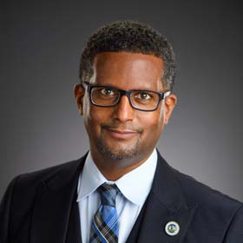

Jordan, Edmond
Dist 29
Democrat
5763 Hooper Road Suite B Baton Rouge, LA 70811-2420
(225) 359-9480
jordane@legis.la.gov
Senate Dist. 2, 14, 15, and 17
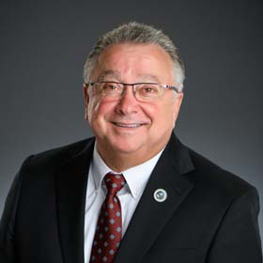

Kerner, Timothy P.
Dist 84
Republican
799 Jean Lafitte Blvd. Lafitte, LA 70067-4102
(504) 689-7725
hse084@legis.la.gov
Senate Dist. 3 and 8
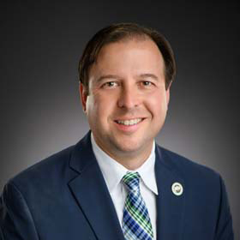

LaCombe, Jeremy
Dist 18
Democrat
P. O. Box 370 Livonia, LA 70755
(225) 637-3803
hse018@legis.la.gov
Senate Dist. 2, 17, and 32
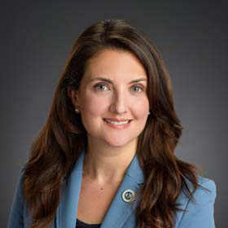

Landry, Mandie
Dist 91
Democrat
2725 South Broad Street Suite 200 New Orleans, LA 70125 *Not ADA accessible. Please call to make accommodations.
(504) 826-2570
hse091@legis.la.gov
Senate Dist. 5
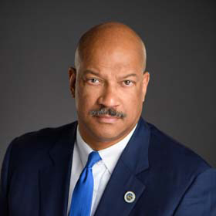

Larvadain III, Ed
Dist 26
Democrat
1811 MacArthur Drive Alexandria, LA 71302
(318) 487-5441
hse026@legis.la.gov
Senate Dist. 29 and 31
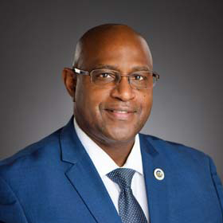

Lyons, Rodney
Dist 87
Democrat
2100 Woodmere Blvd. Suite 130 Harvey, LA 70058
(504) 510-5417
lyonsr@legis.la.gov
Senate Dist. 3, 7, and 8
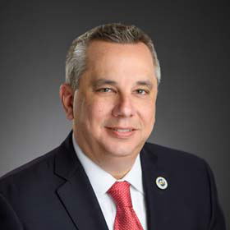

Mack, Sherman Q.
Dist 95
Republican
P. O. Box 115 Albany, LA 70711
(225) 567-3677
macks@legis.la.gov
Senate Dist. 6, 13, and 18
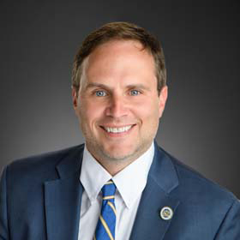

Magee, Tanner
Dist 53
Republican
7833 W. Main Street Houma, LA 70360
(985) 858-2970
mageet@legis.la.gov
Senate Dist. 20 and 21

Marcelle, C. Denise
Dist 61
Democrat
1824 N. Acadian Thruway W. Baton Rouge, LA 70802
(225) 359-9362
marcelled@legis.la.gov
Senate Dist. 14, 15, and 16
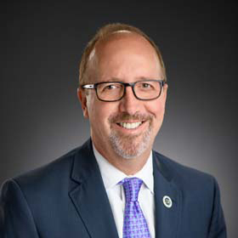

Marino III, Joseph A.
Dist 85
Independent
General Government Building Suite 4300 200 Derbigny Street Gretna, LA 70053
(504) 361-6013
marinoj@legis.la.gov
Senate Dist. 3, 7, and 8
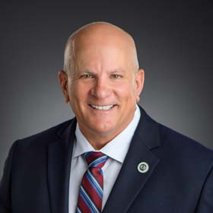

McCormick, Danny
Dist 1
Republican
P. O. Box 160 Oil City, LA 71061
(318) 995-8040
hse001@legis.la.gov
Senate Dist. 36, 38, and 39
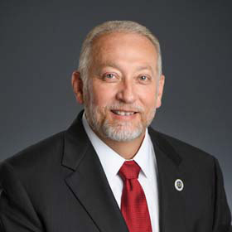

McFarland, Jack
Dist 13
Republican
P. O. Box 143 Jonesboro, LA 71251
(318) 259-4275
mcfarlandj@legis.la.gov
Senate Dist. 29, 31, 35, and 36
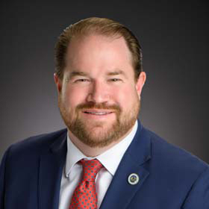

McKnight, Markham Scott
Dist 68
Republican
7901 Wrenwood Blvd. Baton Rouge, LA 70809
(225) 465-5703
hse068@legis.la.gov
Senate Dist. 14 and 16
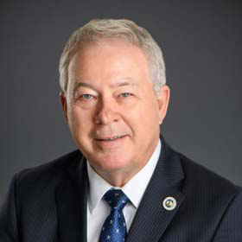

McMahen, Wayne
Dist 10
Republican
736 Main Street Minden, LA 71055
(318) 371-3092
mcmahenw@legis.la.gov
Senate Dist. 36
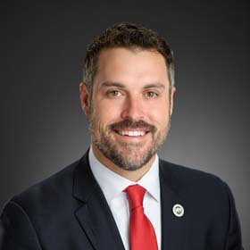

Miguez, Blake
Dist 49
Republican
410 N. Broadway Street Erath, LA 70533
(337) 937-8827
miguezb@legis.la.gov
Senate Dist. 21, 22, and 26
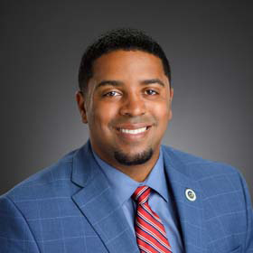

Miller, Dustin
Dist 40
Democrat
Representative Dustin Miller 1310 South Union Street Suite 2 Opelousas, LA 70570
(337) 943-2900
millerd@legis.la.gov
Senate Dist. 24, 26, and 28
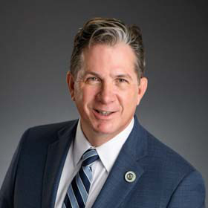

Miller, Gregory A.
Dist 56
Republican
P. O. Box 190 Norco, LA 70079
(985) 764-9991
millerg@legis.la.gov
Senate Dist. 19
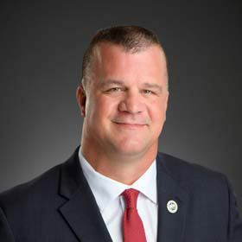

Mincey, Jr., Buddy
Dist 71
Republican
1810 Florida Ave, SW Suite B Denham Springs, LA 70726
(225) 667-6088
hse071@legis.la.gov
Senate Dist. 13

Moore, Pat
Dist 17
Democrat
300 Washington Street Suite 304 Monroe, LA 71201
(318) 362-3014
hse017@legis.la.gov
Senate Dist. 32, 33, 34, and 35
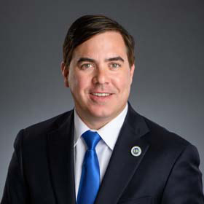

Muscarello, Nicholas
Dist 86
Republican
P. O. Box 1523 Hammond, LA 70404
(985) 974-0009
muscarellon@legis.la.gov
Senate Dist. 6, 11, and 12

Nelson, Richard
Dist 89
Republican
2001 Lakeshore Drive Mandeville, LA 70448
(985) 222-2638
hse089@legis.la.gov
Senate Dist. 11

Newell, Candace N.
Dist 99
Democrat
New Orleans Lake Front Airport Terminal Building Suite 149 6001 Stars and Stripes New Orleans, LA 70126
(504) 240-3435
hse099@legis.la.gov
Senate Dist. 3 and 4
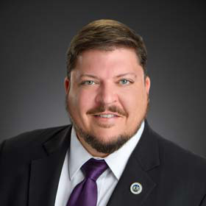

Owen, Robert "Bob"
Dist 76
Republican
1925 Corporate Square Suite C Slidell, LA 70458
(985) 639-0400
hse076@legis.la.gov
Senate Dist. 1
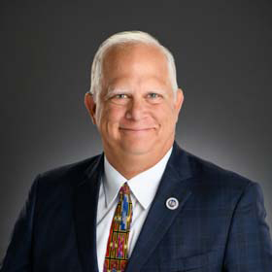

Owen, Charles
Dist 30
Republican
6673 Evans Street Rosepine, LA 70659 Mailing Address: P. O. Box 55 Rosepine, LA 70659
(337) 460-8726
hse030@legis.la.gov
Senate Dist. 30

Phelps, Tammy T.
Dist 3
Democrat
810 E. 70th Street Suite A Shreveport, LA 71106
(318) 862-3080
hse003@legis.la.gov
Senate Dist. 38 and 39
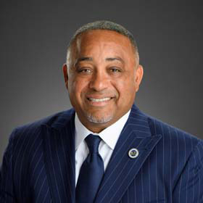

Pierre, Vincent J.
Dist 44
Democrat
800 W. Congress Street Suite A Lafayette, LA 70501
(337) 262-2330
pierrev@legis.la.gov
Senate Dist. 23 and 24
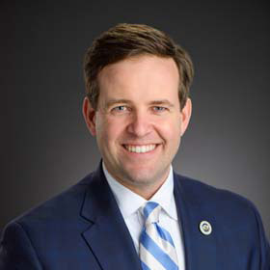

Pressly, Thomas A.
Dist 6
Republican
900 Pierremont Road Suite 119 Shreveport, LA 71106
(318) 862-9920
hse006@legis.la.gov
Senate Dist. 37 and 38
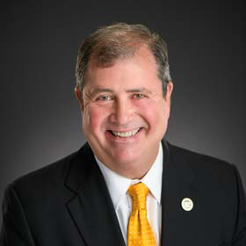

Riser, Neil
Dist 20
Republican
P. O. Box 117 Columbia, LA 71418
(318) 649-0977
risern@legis.la.gov
Senate Dist. 32 and 34
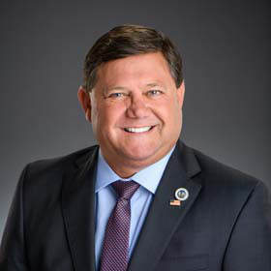

Romero, Troy D.
Dist 37
Republican
P. O. Box 287 Jennings, LA 70546
(337) 824-0376
hse037@legis.la.gov
Senate Dist. 25
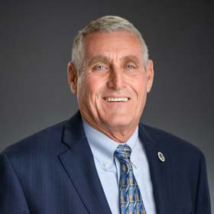

Schamerhorn, Rodney
Dist 24
Republican
P. O. Box 83 Hornbeck, LA 71439
(318) 565-4959
hse024@legis.la.gov
Senate Dist. 30 and 31
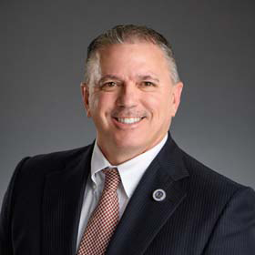

Schexnayder, Clay
Dist 81
Republican
6473 Highway 44 Suite 205 Gonzales, LA 70737
(225) 473-6016
schexnayderc@legis.la.gov
Senate Dist. 2, 13, and 18
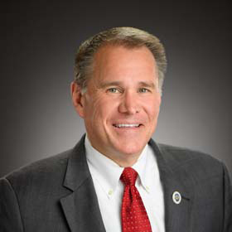

Seabaugh, Alan
Dist 5
Republican
401 Market Street Suite 1150 Shreveport, LA 71101
(318) 676-7990
seabaugha@legis.la.gov
Senate Dist. 37, 38, and 39
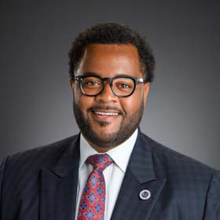

Selders, Larry
Dist 67
Democrat
251 Florida Street Suite 300 Baton Rouge, LA 70801
(225) 342-7106
hse067@legis.la.gov
Senate Dist. 14
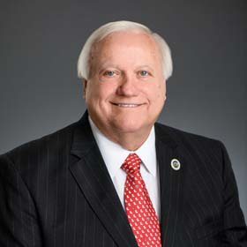

St. Blanc III, Vincent "Vinney"
Dist 50
Republican
733 Main Street Franklin, LA 70538
(337) 828-7778
hse050@legis.la.gov
Senate Dist. 17 and 21
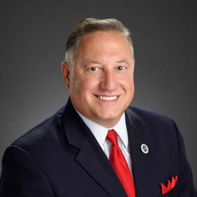

Stagni, Joseph A.
Dist 92
Republican
1201 Williams Blvd. Kenner, LA 70062
(504) 465-3479
stagnij@legis.la.gov
Senate Dist. 10 and 19
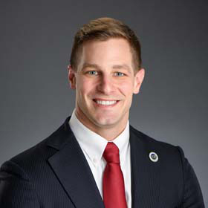

Stefanski, John M.
Dist 42
Republican
P. O. Box 2720 Crowley, LA 70527-2720
(337) 384-8999
stefanskij@legis.la.gov
Senate Dist. 25 and 26
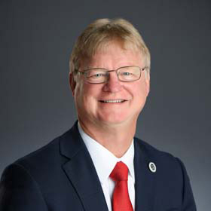

Tarver, Phillip Eric
Dist 36
Republican
132 Jamestown Lake Charles, LA 70605
(337) 475-8186
hse036@legis.la.gov
Senate Dist. 25 and 27

Thomas, Polly
Dist 80
Republican
3100 Ridgelake Drive Suite 201 Metairie, LA 70002-4938
504-83POLLY (837-6559)
thomaspj@legis.la.gov
Senate Dist. 9

Thompson, Francis C.
Dist 19
Democrat
P. O. Box 68 Delhi, LA 71232
(318) 878-9408
thompsof@legis.la.gov
Senate Dist. 32, 33, and 34

Turner, Christopher
Dist 12
Republican
207 W. Mississippi Street Suite 306 Ruston, LA 71270
(318) 251-5038
hse012@legis.la.gov
Senate Dist. 33 and 35
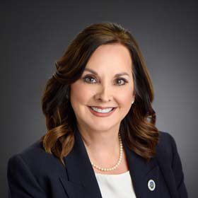

Villio, Debbie
Dist 79
Republican
4203 Williams Blvd. Suite 200 Kenner, LA 70065
(504) 468-8603
hse079@legis.la.gov
Senate Dist. 9 and 10
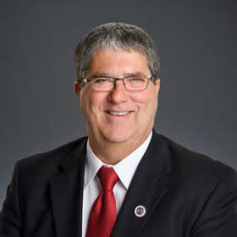

Wheat Jr., William "Bill"
Dist 73
Republican
P. O. Box 2473 Ponchatoula, LA 70454
(985) 386-7844
hse073@legis.la.gov
Senate Dist. 6, 11, and 13

White, Malinda
Dist 75
Democrat
116 Georgia Ave. Suite B Bogalusa, LA 70427
(985) 730-2147
whitema@legis.la.gov
Senate Dist. 12
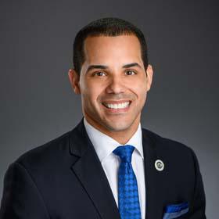

Willard, Matthew
Dist 97
Democrat
UNO TRAC Building Room 212 2000 Lakeshore Drive New Orleans, LA 70148
(504) 283-4261
hse097@legis.la.gov
Senate Dist. 3, 4, and 5

Wright, Mark
Dist 77
Republican
312 South Jefferson Street Suite A & B Covington, LA 70433
(985) 893-6262
wrightm@legis.la.gov
Senate Dist. 11 and 12
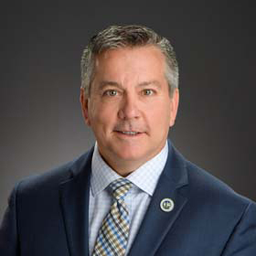

Zeringue, Jerome
Dist 52
Republican
423 Goode Street Houma, LA 70360
(985) 876-8823
zeringuej@legis.la.gov
Senate Dist. 20 and 21
LOUISIANA HOUSE OF REPRESENTATIVES BOX 94062 (900 NORTH 3RD STREET) BATON ROUGE, LOUISIANA 70804

