STATE COORDINATOR SPRING REPORT

Thanks to all who have worked so hard in composing a presentation for the LEADERSHIP TRAINING MEETING to be held June 23 – 24, 2023. We are excited to see the Presidents and their council leaders/members at this event. Come join us at the meeting by clicking on this link at the bottom of the invitation below:

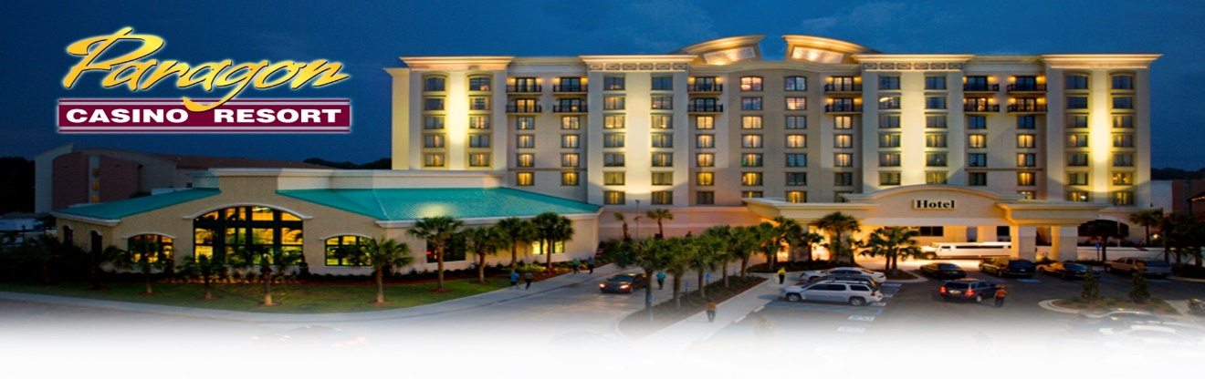

Please join us . . .

LRA Leadership Meeting & Awards Banquet

**Friday 6.23.23 2:00-8:00 PM and Saturday 6.24.23 8:00 AM-1:00 PM**

**Paragon Casino Hotel and Resort**

**711 Paragon Place, Mansura/Marksville, LA 71350**

**Registration Deadline: June 9, 2023**

**Attendees**

• Local Council Officers, Members, and Guests

• LRA BOD and Committee Chairs

**Objectives**

• Prepare members & leaders for roles in state and local councils

• Install NEW local and state officers

• Discuss strengths & challenges affecting membership

• Engage in professional learning with guest speaker

• Celebrate members & award recipients at the Awards Banquet

• Showcase local council and LRA accomplishments

• Discuss the next LRA State Conference

**Gift Baskets & Presentations**

• Local Council Presidents & VP donate two gift baskets to use as door prizes. Gift baskets should include items educators would enjoy. Please put your council’s name on each gift basket and turn them in at sign-in on 6/23/23.

**Lodging** • Please book your own room for one night (June 23, 2023) at the Paragon by **6/9/23**. Call 1-800-642-7777 and provide RES ID CODE: **LRRJ23G** for a North/South Tower room at $94/night. Two complimentary rooms are allowed per local council. Bring a tax-exempt letter from your school/district and present it to the front desk upon check-in to avoid taxes. Bring your hotel receipt to the Leadership meeting on Saturday for reimbursement of $94 from LRA. The $15 Resort Fee will be given back to you as Free Play on a Paragon Player’s Card.

**Mileage**

• LRA will reimburse mileage for two cars per local council at .30/mile. Show your travel from your destination to the Paragon on the Travel Voucher. The Treasurer will double-check the mileage calculations for reimbursement.

**Dress Code** • Casual or business casual for Leadership meetings. • Church or business dress for the Awards Banquet.

**Meals**

• 6/23/23 Awards Ceremony Dinner: $25/pp. No cost to award recipients plus 1 guest. Register and pay online here.

• 6/24/23 Breakfast. Please check breakfast only if you can participate.

**Contacts**

* Christy Mayfield, christy.mayfield@stpsb.org, 985.768.2133
* Gerri Settoon, gerri.settoon@gmail.com, 504.554.9315
* Veronica Governale, [readingvg423@gmail.com](mailto:readingvg423@gmail.com)

**Thank you for all that you do. We look forward to reconnecting through literacy!**

**Complete Registration via this link to register:** <https://form.jotform.com/231495276457163>